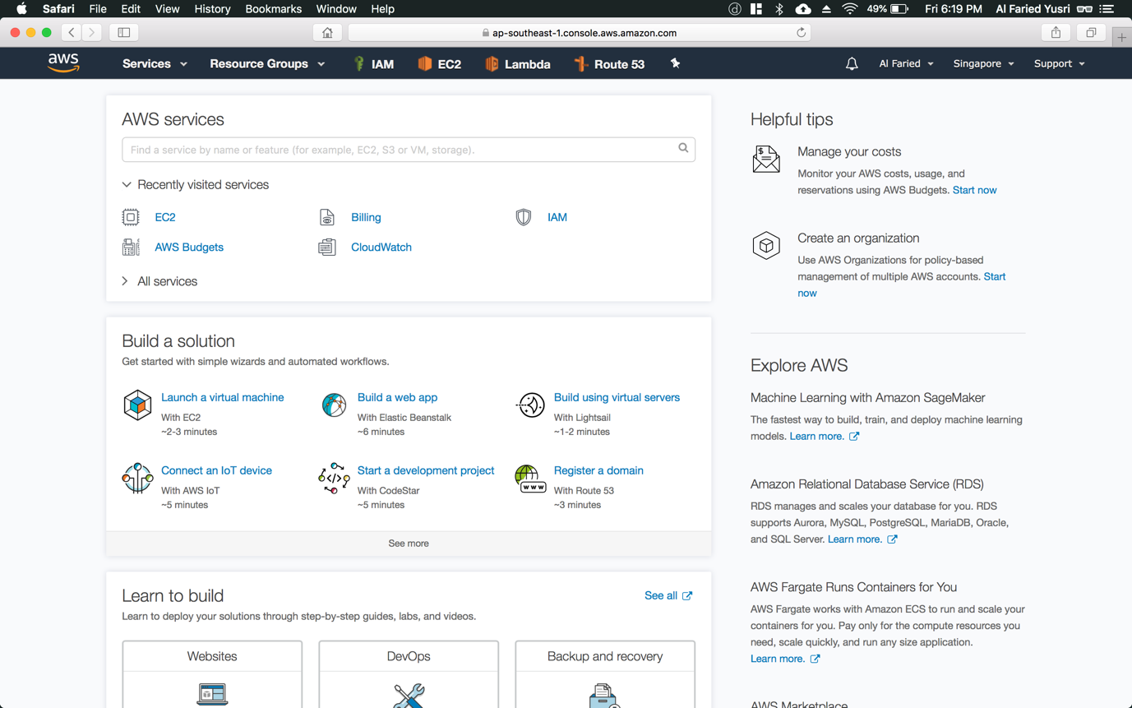

Step 1: Once you’re back on your AWS Management Console, click on “Services” (refer to Figure 1.1) on the top left-hand corner

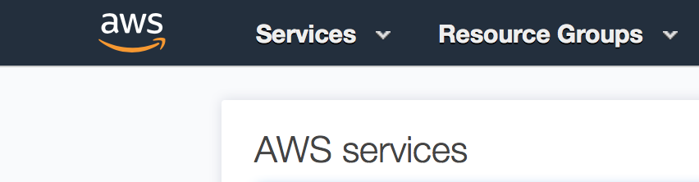

Figure 1.1

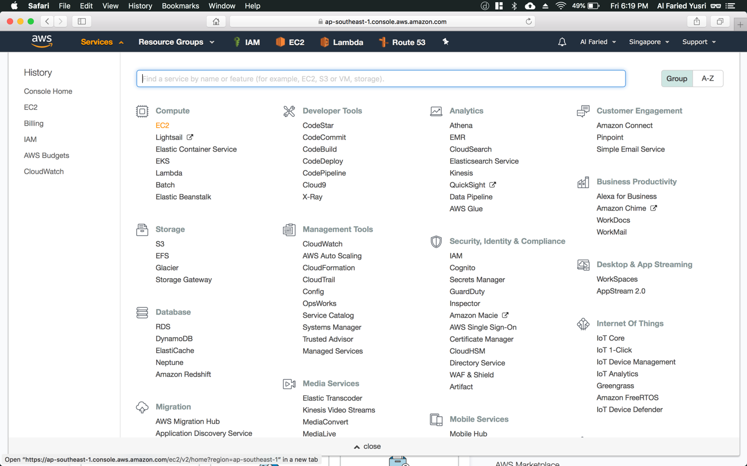

Step 2: Click “EC2” – The one that is highlighted in orange

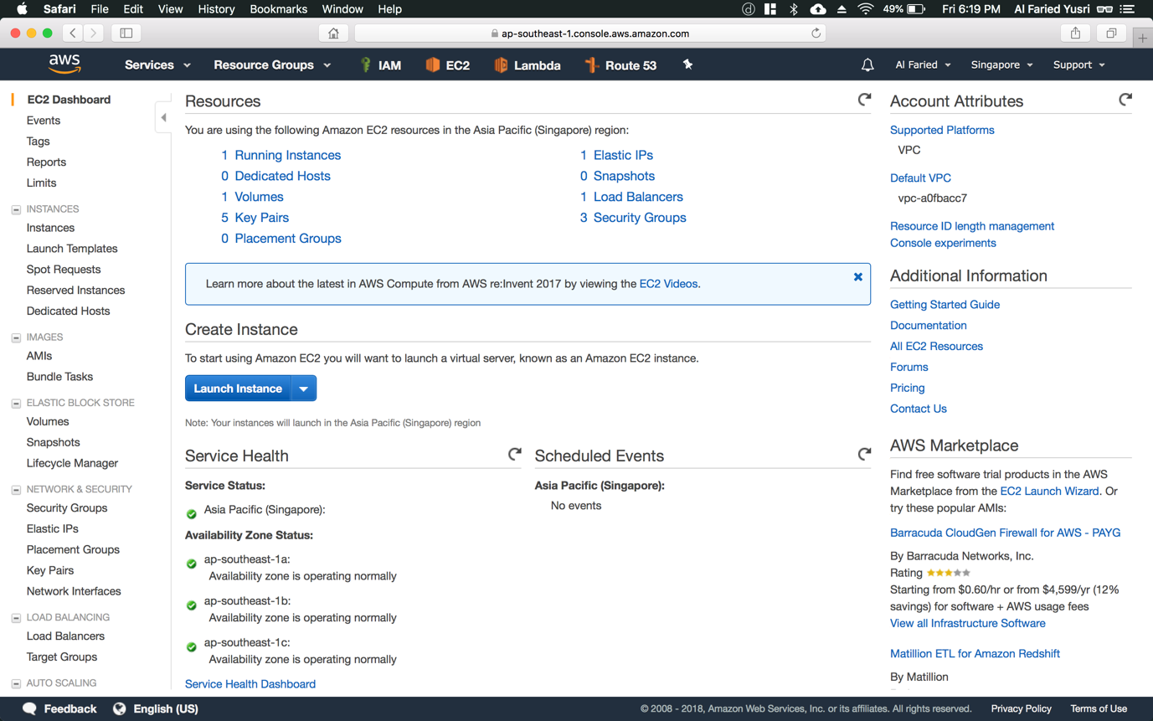

Step 3: On this page, click on “Elastic IPs” option under the “NETWORK & SECURITY” category (refer to Figure 1.2)

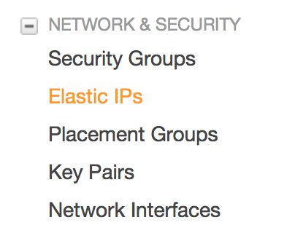

Figure 1.2

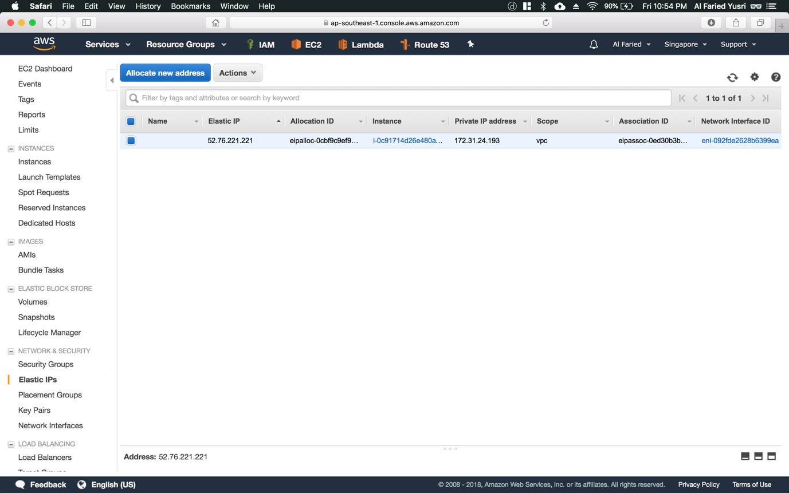

Step 4: Once greeted with this page, click on “Allocate new address” button

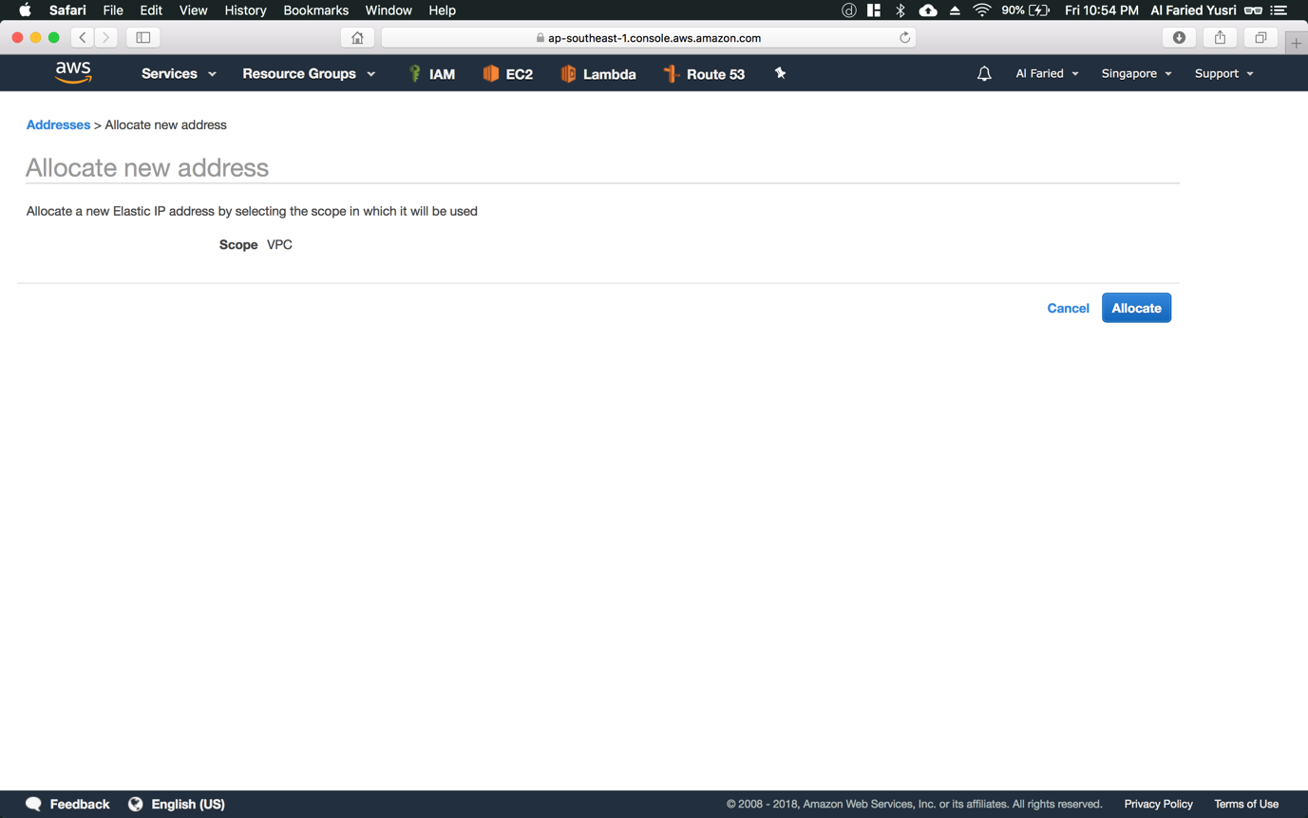

Step 5: On this page, click on “Allocate” button

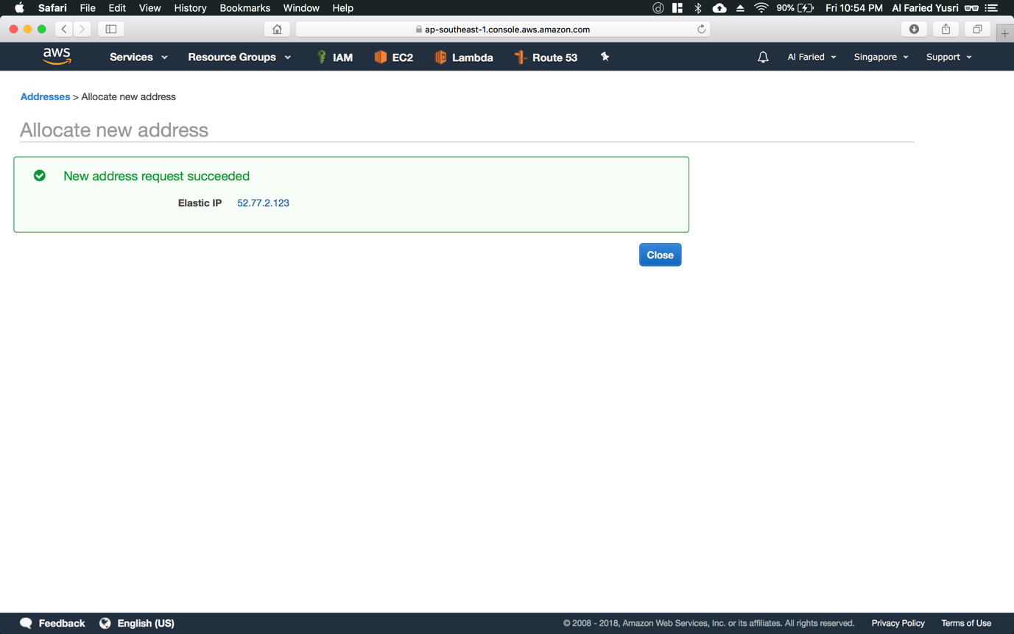

Step 6: After allocating new address, just click close where it will bring you back to the Elastic IPs homepage

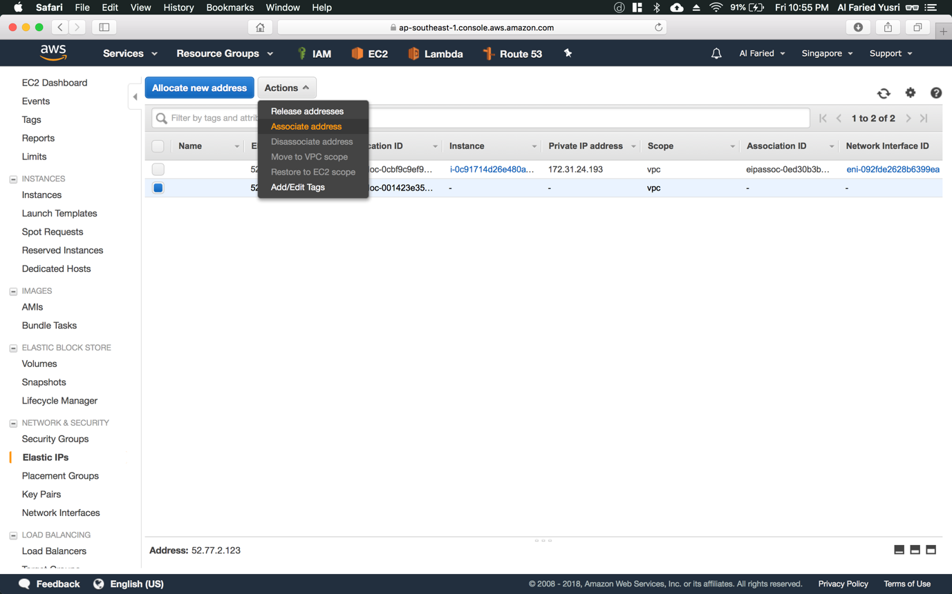

Step 7: Back on this page, select the newly allocated Elastic IP and click on the “Actions” button beside the “Allocate new address” button. Subsequently, click on the “Associate address” option.

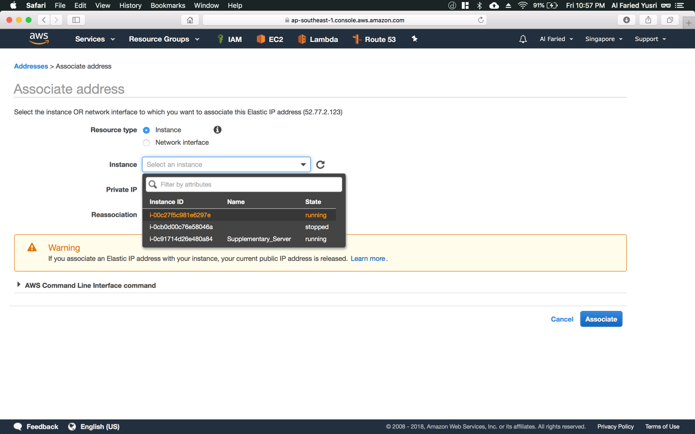

Step 8: You will be greeted with this page. Here, click on the Instance drop-down list and select the newly launched instance

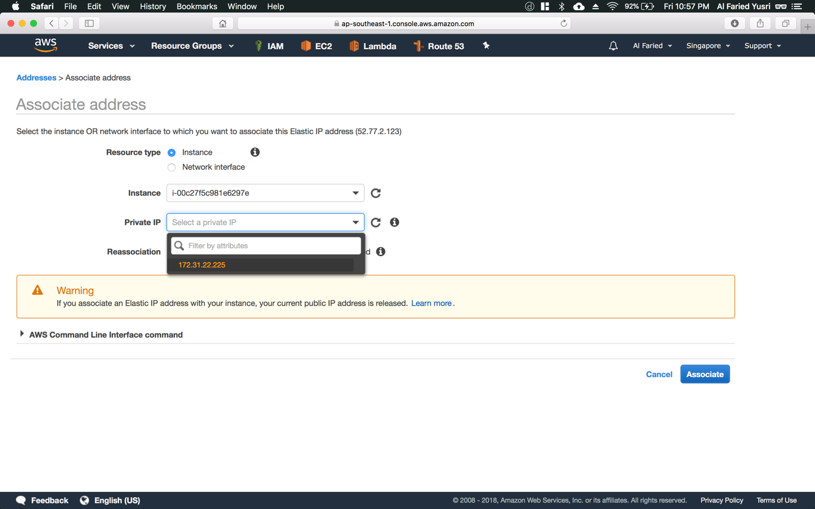

Step 9: Next, click on the Private IP dropdown list and select the associated IP address.

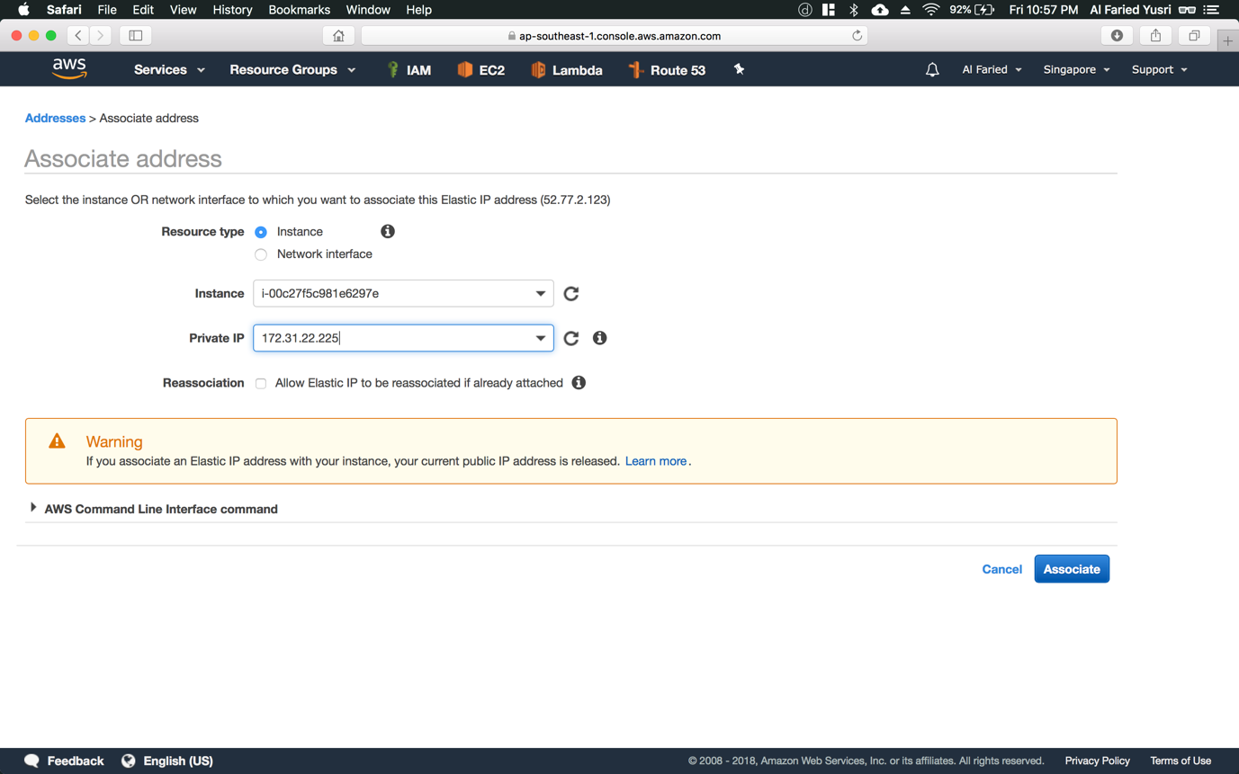

Step 10: Once done, select the “Associate” button

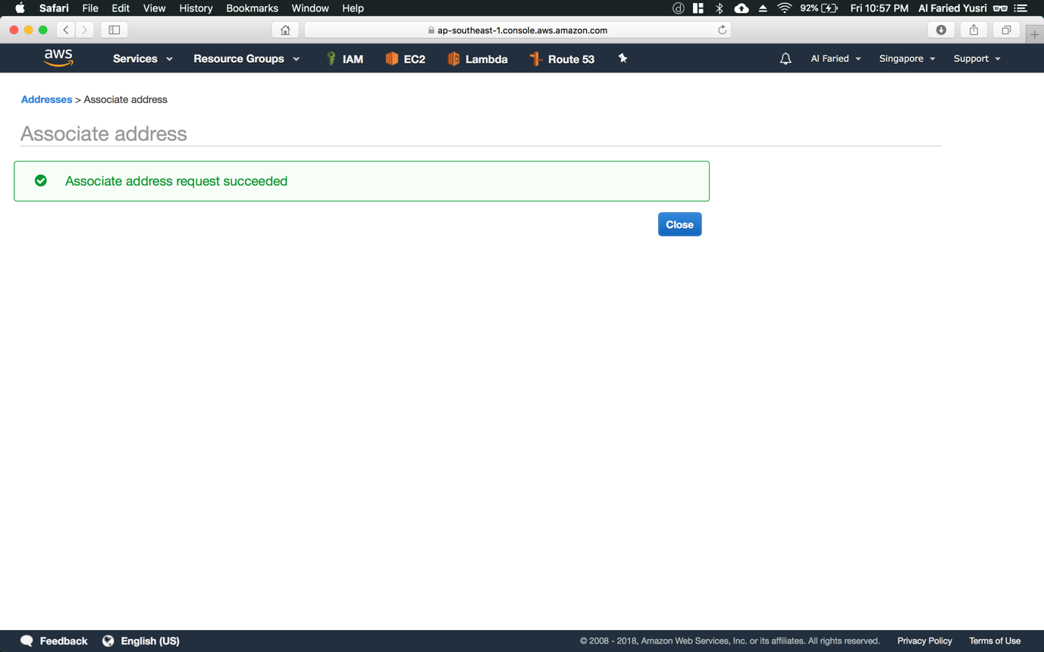

Step 11: Then just click close, where it will bring you back to the Elastic IPs homepage

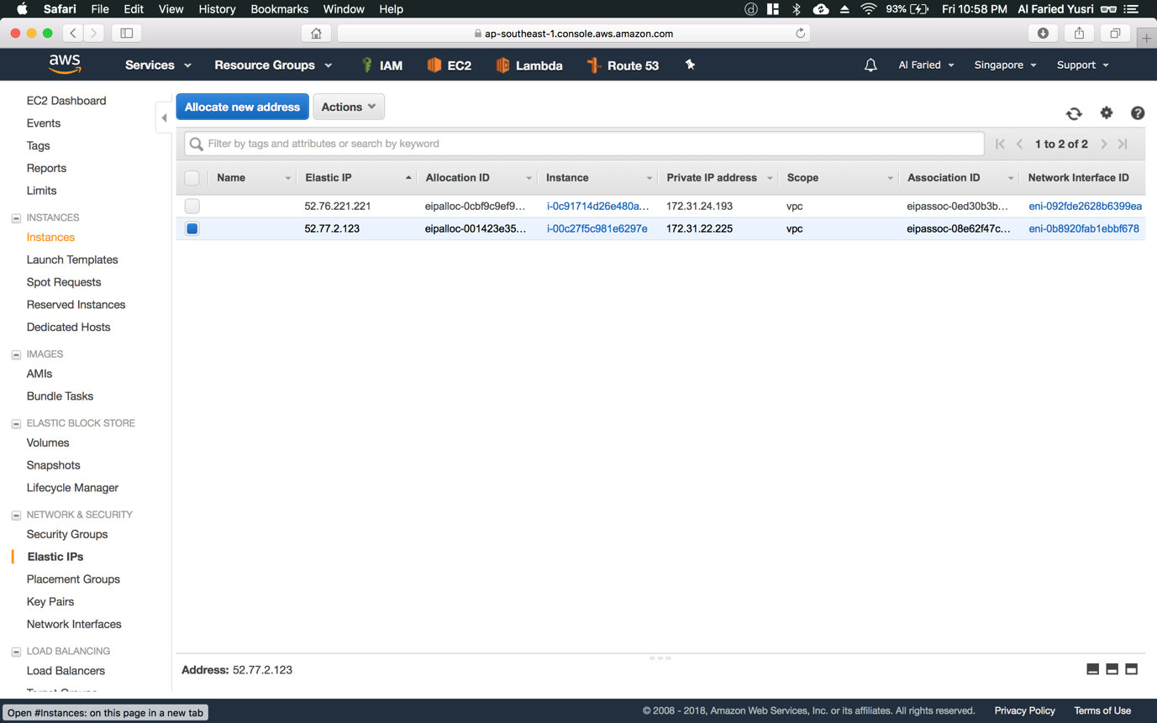

Step 12: On this page, select the “Instance” option within the “INSTANCES” category (refer to Figure 2.1)

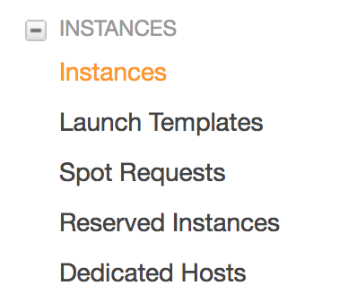

Figure 2.1

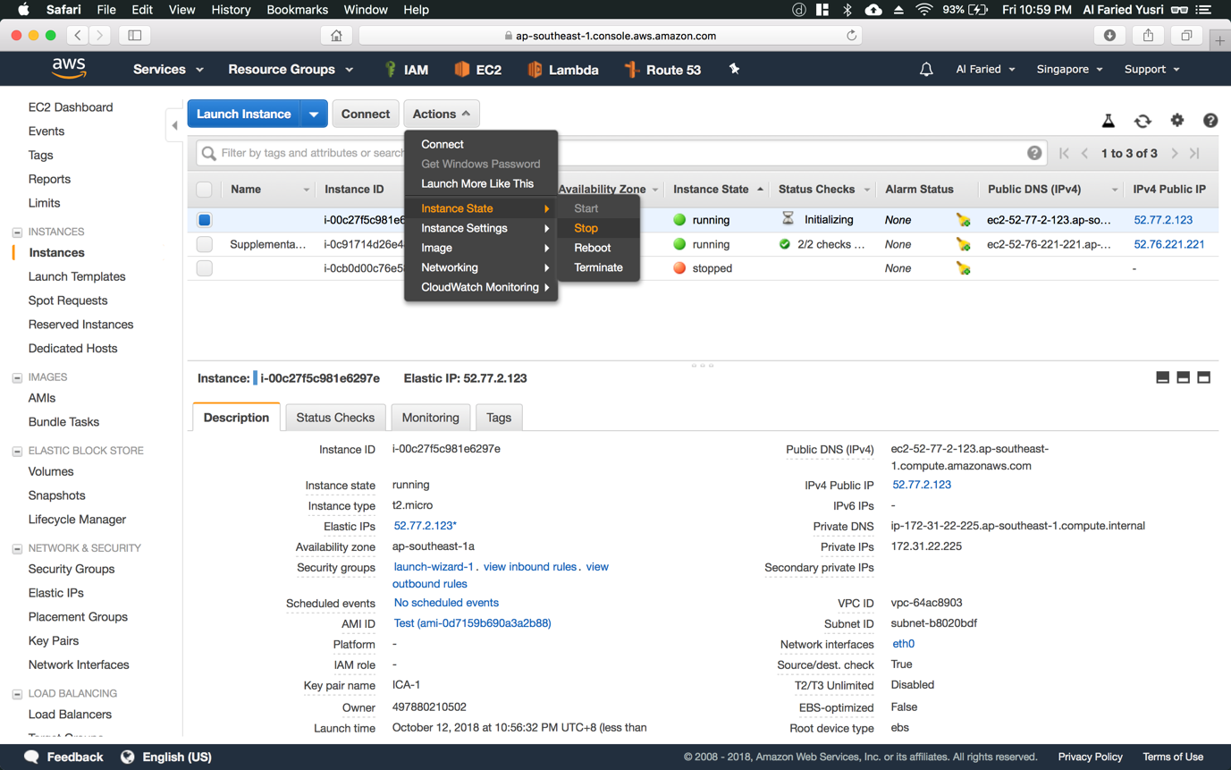

Step 13: After associating your instance to the Elastic IP, you will need to restart the server in order for it to register the changes. On this page, select on the newly create instance which you’ve associated the Elastic IP to and select the “Actions” button at the top. Next select the “Instance State” option and click on the “Stop” option. The instance should reflect “stopped” after several seconds (refer to Figure 3.1)

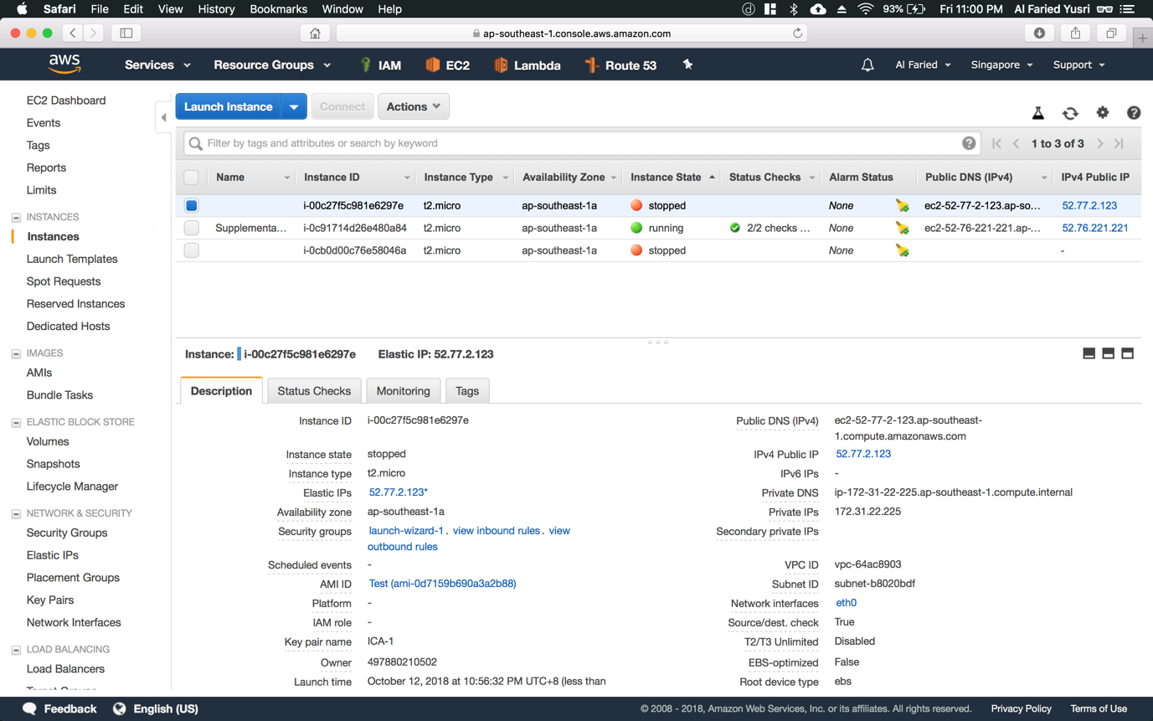

Figure 3.1

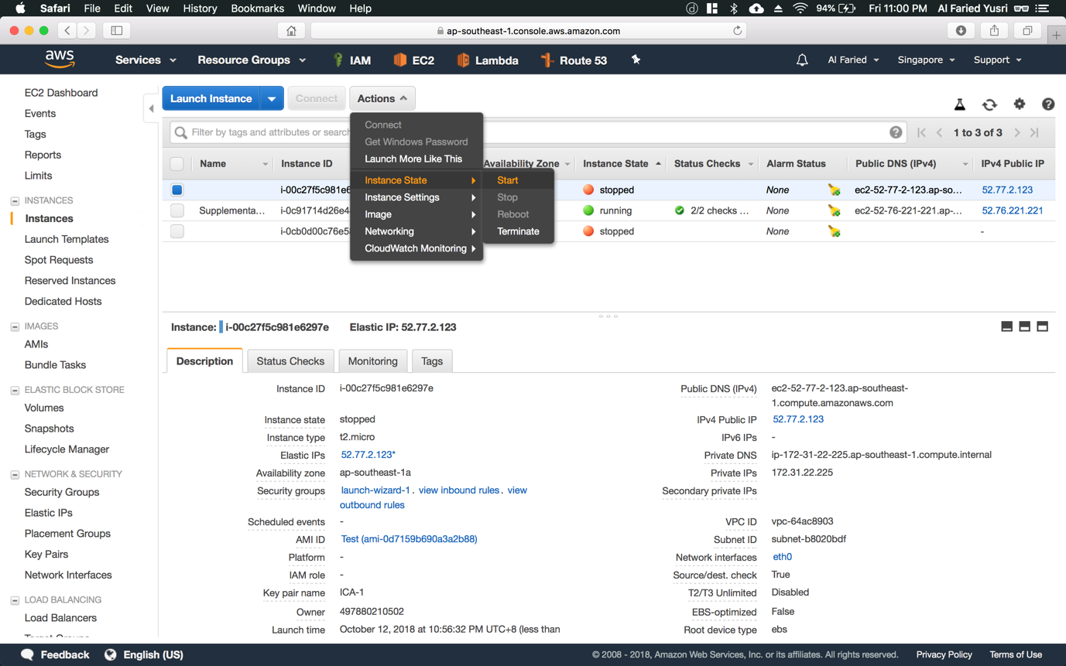

Step 14: Now we’ll have to start the instance. So, select the stopped instance and click on the “Actions” button and scroll to “Instance State” option and click on the “Start” option. Wait a couple of seconds for the instance to start up and initialize itself.